**328754791**

**Heuristic function :**

Manhattan distance = The sum of the horizontal and vertical distances between Node to goal

**Admissible:**

• The heuristic function h(n) is called admissible if h(n) is never larger than h*(n), namely h(n) is always less or equal to true cheapest cost from n to the goal.

The Manhattan distance is an admissible heuristic in this case because every state that not in his position will have to be moved at least the number of spots in between itself and its goal position.

so h(n)<= h*(n), while h*(n), is the exact lowest cost from node n-> to goal as required.

**Consistent:**

• A heuristic is consistent if for every node n, every successor n' of n generated by any ,

h(n) ≤ c(n,a,n') + h(n') were a is operator(Left,Right,Up,Down)

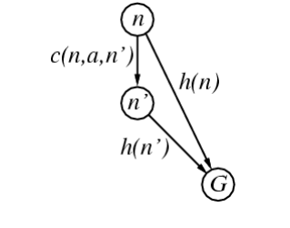

c(n,n') is the cheapest path between n->n'

need to proof: h(n) <= c(n,n') + h(n')

if h(n') >= h(n), since c(n,n') is always positive means h(n) <= c(n,n') + h(n') as required.

if h(n') <= h(n), this means we moved operator to the goal direction but because h is admissible

every node we moved entered c(n,n') and h(n)-h(n')<=c(n,mn' as required.